COLEGIO VILLA SANTA MARÍA

COORDINACIÓN ACADÉMICA (CIENCIAS / HUMANIDADES)  **A**

PROFESOR: CLAUDIO VARAS

**___________________________________________________________________**

**Calificación**

Guía de Autoaprendizaje

**ENGLISH AS A FOREIGN LANGUAGE**

**UNIDAD 0**

Nombre: ___________________________________ Curso: ____1° medio______ Fecha de entrega: __20 de marzo____

|  |  |
| --- | --- |
| **OA:** | * Identificar y utilizar vocabulario temático a partir de pistas contextuales. * Identificar y utilizar conectores de oración en contextos escritos. * Leer textos y recordar hechos y detalles; identificar tipo y propósito de éste; identificar la idea principal; reconocer causa y efecto; comparar y contrastar; hacer predicciones y sacar conclusiones. * Escuchar audio e identificar información específica. |

|  |
| --- |
| **INSTRUCCIONES:**  Este material puede ser impreso para ser realizado a mano, o bien puede ser transformado a Word para ser llenado. En caso de que el alumno no cuente con acceso a impresión, el material puede ser retirado en el establecimiento.  Una vez resuelta la guía debe ser escaneada o fotografiada y enviada al correo del profesor que se señala a continuación. Si no cuenta con los accesos para realizar esta acción puede concurrir al establecimiento, siempre y cuando las medidas de salud lo permitan. Este es con el fin de retroalimentar el proceso de aprendizaje que se está realizando. |
| **MAIL DE RECEPCIÓN:claudiovars@gmail.com** |

|  |  |  |  |  |  |  |  |  |  |  |  |  |  |  |  |
| --- | --- | --- | --- | --- | --- | --- | --- | --- | --- | --- | --- | --- | --- | --- | --- |
| Rúbrica:   |  |  |  | | --- | --- | --- | |  | Puntaje ideal | Puntaje real | | Circle the correct alternative | 5 |  | | Circle the correct alternative | 8 |  | | Read the text and circle the correct alternative | 10 |  | | TOTAL | 23 |  | |

**I. Circle the correct alternative.** 1p/each.

**1.** _____________ I studied for the test, I got 3,0.

**a-** However **b-** besides **c-** although

**2.** I don’t like hamburgers because they are horrible. ____________, they have too much cholesterol.

**a-** However **b-** besides **c-** although

**3.** Russians do not like The USA. ___________, many speak English perfectly.

**a-** However **b-** besides **c-** although

**4.** Tom lives in Jamaica. ___________, he dislikes tropical climate.

**a-** However **b-** besides **c-** although

**5.** I don’t like that book. It’s tedious. ___________, its author is a racist.

**a-** However **b-** besides **c-** although

**II. Circle the correct alternative.** 1p/each.

**1. Many students protested against the ………………………**

**a-** crops **b-** agrarian **c-** government **d-** deer

**2. It’s is important to respect people’s customs and ……………….…**

**a-** deer  **b-** beliefs **c-** hunter **d-** way

**3. The descendants of the Inca continue plant ……………….…**

**a-** wisdom  **b-** governments **c-** customs **d-** crops

**4. It is a traditional…………………… to dance *cueca* on Independece Day.**

**a-** custom **b-** deer  **c-** wisdom **d-** fisherman

**5. The Onas had a nomadic ………………… of life.**

**a-** crops **b-** wisdom **c-** way **d-** agrarian

**6. The Mapuche are an……………………….people.**

**a-** crops **b-** agrarian **c-** beleif **d-** deer

**7. Ignorance is an antonym for …………………**

**a- c**rops **b-** fisherman **c-** punish **d-** wisdom

**8. The purpose of judicial institutions is to.……………. crime.**

**a-** punish **b-** belief **c-** agrarian **d-** nomads

**III. Read the text and circle the correct alternative.** 1p/each.

**Cherokee Social Structure**

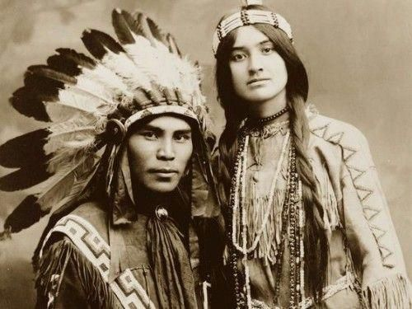

The Cherokee people are the largest indigenous group on the North American continent. Like many other indigenous peoples, their society changed drastically when the European colonists arrived. However, before the Europeans came to the Americas, the Cherokee had a very well-established social structure. Although the Cherokee were colonized and dominated, many of their cultural practices from the past continue to be part of modern Cherokee culture.

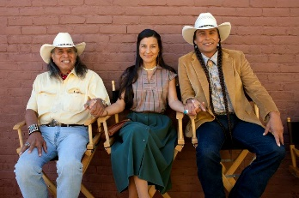

**Social Organization**

In the Cherokee culture, the oldest members of the community were given the highest prestige and respect. Age was the primary indicator of wisdom and status. Besides, women and men were considered equal.

**Political Organization**

The Cherokees had two different government bodies to control their tribes. There was a white government which served during peace times and had control over the community. The other government body was the red government, which controlled aspects of war and conflict.

**Social Control**

In Cherokee society, people were punished for conflict in subtle ways. Public humiliation and social distance were used to punish people and to prevent them from fighting. There was also a strong fear of punishment from the Cherokee gods.

Taken and adapted from: [www.blogspot.com/indigenous.culture/nativeamericangroups.com](http://www.blogspot.com/indigenous.culture/nativeamericangroups.com)

|  |  |
| --- | --- |
| **1. Cherokee society was considerably impacted by:**   1. Colonists from Europe. 2. A larger indigenous group. 3. African invaders. | **6. According to paragraph 4, It’s probable that:**   1. The Cherokee did not like social conflict. 2. The Cherokee promoted conflict. 3. Loved to punish people. |
| **2. Colonization:**   1. Destroyed Cherokee culture. 2. Did not destroy Cherokee culture. 3. Is the name of the Cherokee language. | **7. In general, the text describes:**   1. The Cherokee were agrarians. 2. Cultural aspects of the Cherokee. 3. The Cherokee were vegetarian. |
| **3. When Cherokee people turned 60 years old:**   1. They respected men and women. 2. They transformed into animals. 3. They were admired and respected. | **8. The purpose of the text is to:**   1. Convince. 2. Instruct. 3. Inform. |
| **4. MEN and WOMEN were treated:**   1. Equally 2. Differently. 3. Terribly. | **9. The text is _______.**   1. Instructive. 2. Informative. 3. Argumentative. |
| **5. What government administered territory defense?**   1. White. 2. Red. 3. Black. | **10. The text is from a…**   1. A newspaper. 2. A catalogue. 3. A webpage. |