**Calificación**

Guía de Autoaprendizaje

matemática

**UNIDAD I: Contando números**

Nombre: ___________________________________________ Curso: 1° básico

|  |  |
| --- | --- |
| **Objetivo:** | Contar hasta 10.  Contar de 1 en 1, 2 en 2, de 5 en 5.  Leer y representar números hasta 10. |

|  |
| --- |
| **INSTRUCCIONES GENERALES:**  Al término de la Guía, esta debe ser archivada en una carpeta para ser presentada al final del período de suspensión de clases. |
| **MAIL DE CONSULTA Y RETROALIMENTACIÓN:** katamunozcruz@yahoo.cl |

|  |  |  |  |  |  |  |  |  |  |  |  |  |  |  |  |
| --- | --- | --- | --- | --- | --- | --- | --- | --- | --- | --- | --- | --- | --- | --- | --- |
| Rúbrica:   |  |  |  | | --- | --- | --- | | Indicadores | Puntaje ideal | Puntaje real | | Escribe números hasta 10. | 11 |  | | Contar hasta 10. | 15 |  | | Cuenta de 1 en 1 y de 2 en 2. | 10 |  | | Total | 36 |  | |

1.- Escribe los números hasta 10:

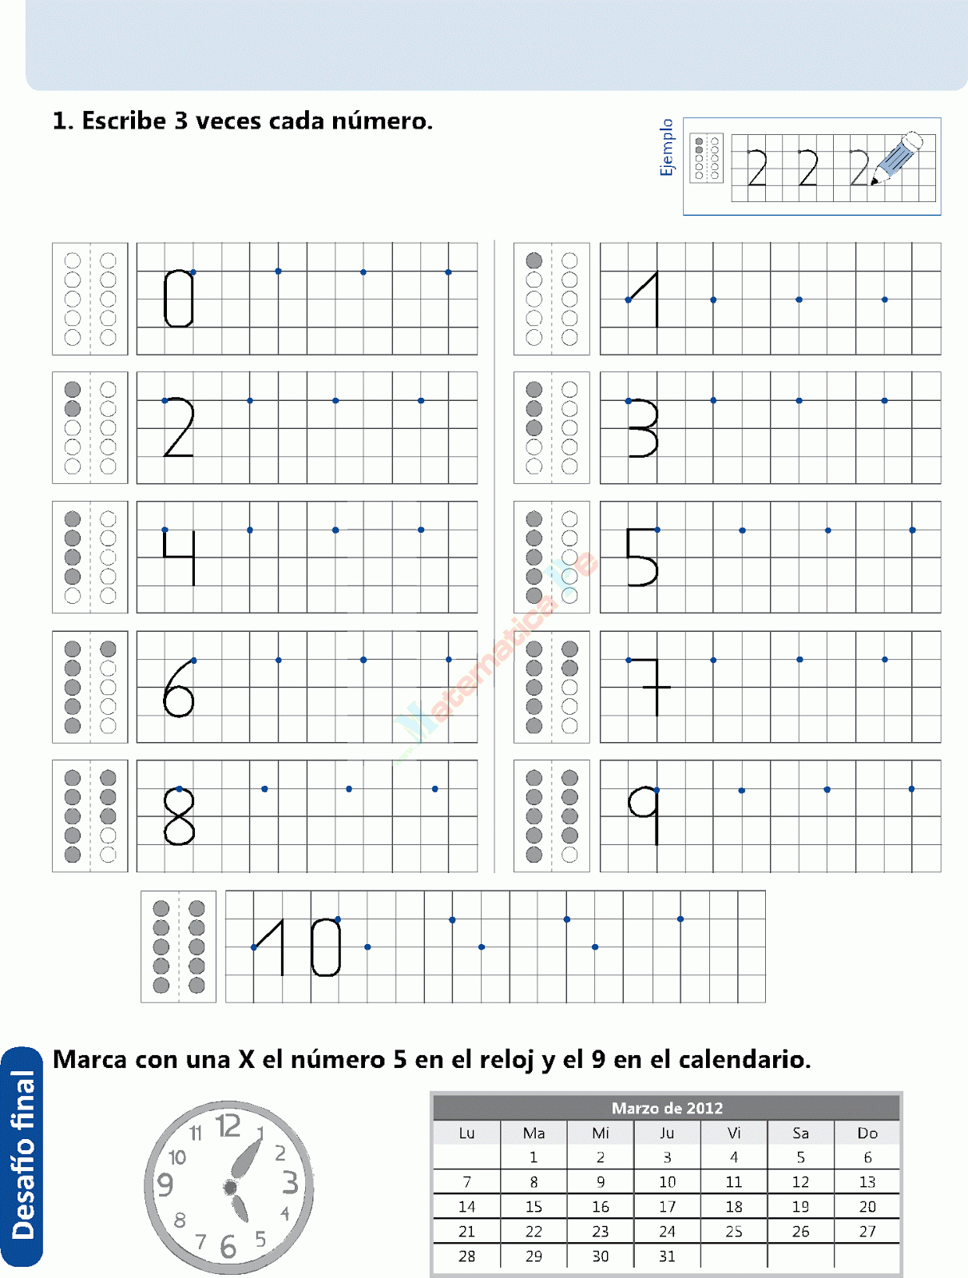

2.- Observa la imagen, cuenta y completa con la cantidad que corresponde: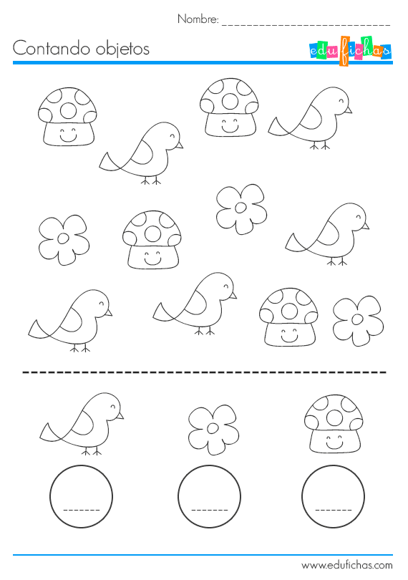

2.- Observa las imágenes, cuenta y **pinta el casillero con el número** que corresponde:

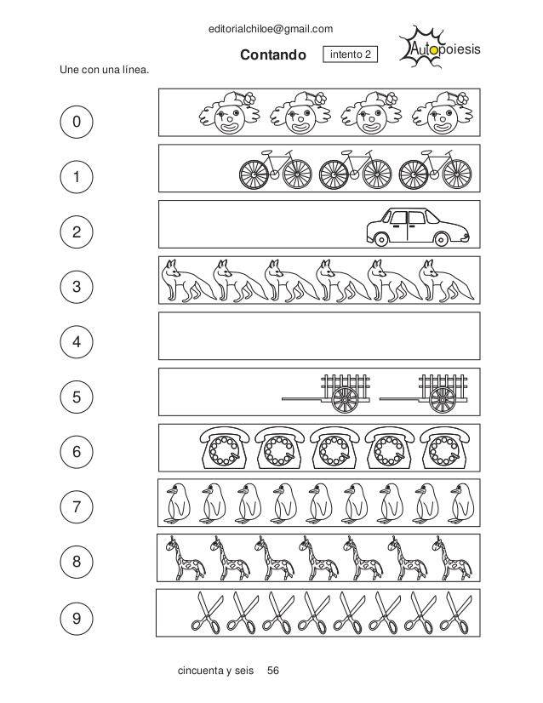

|  |  |  |  |  |  |  |  |  |  |  |
| --- | --- | --- | --- | --- | --- | --- | --- | --- | --- | --- |
| 0 | 1 | 2 | 3 | 4 | 5 | 6 | 7 | 8 | 9 | 10 |



|  |  |  |  |  |  |  |  |  |  |  |
| --- | --- | --- | --- | --- | --- | --- | --- | --- | --- | --- |
| 0 | 1 | 2 | 3 | 4 | 5 | 6 | 7 | 8 | 9 | 10 |



|  |  |  |  |  |  |  |  |  |  |  |
| --- | --- | --- | --- | --- | --- | --- | --- | --- | --- | --- |
| 0 | 1 | 2 | 3 | 4 | 5 | 6 | 7 | 8 | 9 | 10 |



|  |  |  |  |  |  |  |  |  |  |  |
| --- | --- | --- | --- | --- | --- | --- | --- | --- | --- | --- |
| 0 | 1 | 2 | 3 | 4 | 5 | 6 | 7 | 8 | 9 | 10 |



|  |  |  |  |  |  |  |  |  |  |  |
| --- | --- | --- | --- | --- | --- | --- | --- | --- | --- | --- |
| 0 | 1 | 2 | 3 | 4 | 5 | 6 | 7 | 8 | 9 | 10 |

3.- Lee el número y **pinta la cantidad de cuadros** que corresponde:

|  |  |  |  |  |  |  |  |  |  |
| --- | --- | --- | --- | --- | --- | --- | --- | --- | --- |
| 8 |  |  |  |  |  |  |  |  |  |

|  |  |  |  |  |  |  |  |  |  |
| --- | --- | --- | --- | --- | --- | --- | --- | --- | --- |
| 4 |  |  |  |  |  |  |  |  |  |

|  |  |  |  |  |  |  |  |  |  |
| --- | --- | --- | --- | --- | --- | --- | --- | --- | --- |
| 5 |  |  |  |  |  |  |  |  |  |

|  |  |  |  |  |  |  |  |  |  |
| --- | --- | --- | --- | --- | --- | --- | --- | --- | --- |
| 7 |  |  |  |  |  |  |  |  |  |

|  |  |  |  |  |  |  |  |  |  |
| --- | --- | --- | --- | --- | --- | --- | --- | --- | --- |
| 1 |  |  |  |  |  |  |  |  |  |

4.- Completa las tablas numéricas contando de 1 en 1 y luego 2 en 2:

|  |  |  |  |  |  |  |  |  |  |  |
| --- | --- | --- | --- | --- | --- | --- | --- | --- | --- | --- |
| 0 | 1 |  |  |  |  | 6 |  |  |  |  |

|  |  |  |  |  |  |
| --- | --- | --- | --- | --- | --- |
| 0 | 2 |  | 6 | 8 |  |

5.- Completa las imágenes que faltan en cada caso:

**6**

**3**