**Calificación**

Guía de Autoaprendizaje

Lenguaje y comunicación

**UNIDAD 0:Vocales.**

**Nombre**: _______________________________________**Curso:**1° básico

|  |  |
| --- | --- |
| **Objetivos:** | * Leer y escribir vocales. * Escribir su nombre y apellido con letra manuscrita. |

|  |
| --- |
| **INSTRUCCIONES GENERALES:**  Al término de la Guía, esta debe ser archivada en una carpeta para ser presentada al final del período de suspensión de clases.. |
| **MAIL CONSULTA Y RETROALIMENTACIÓN:** katamunozcruz@yahoo.cl |

|  |  |  |  |  |  |  |  |  |  |  |  |  |
| --- | --- | --- | --- | --- | --- | --- | --- | --- | --- | --- | --- | --- |
| **Rúbrica:**   |  |  |  | | --- | --- | --- | | Indicadores | Puntaje ideal | Puntaje real | | Leer y escribir vocales iniciales. | 24 |  | | Escritura de nombre y apellido. | 2 |  | | Total | 26 |  | |

1.- Observa cada imagen y escribe su vocal inicial:

|  |  |  |
| --- | --- | --- |
| Resultado de imagen para ardilla para colorear | Resultado de imagen para arbol para colorear | Resultado de imagen para uva para colorear |
| Resultado de imagen para elefante para colorear  Resultado de imagen para uslero para colorear | Resultado de imagen para iguana para colorear | Resultado de imagen para oso para colorear |
| Resultado de imagen para oveja para colorear |  | Resultado de imagen para escalera para colorear |

2.- Une cada imagen a su sílaba inicial:



**u**



**e**



**o**



**a**



**i**

3.- Escribe la vocal inicial al lado de cada imagen:

|  |  |  |  |
| --- | --- | --- | --- |
|  |  |  |  |
|  |  |  |  |
|  |  |  |  |

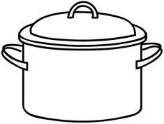

|  |  |  |  |
| --- | --- | --- | --- |
|  |  |  |  |
|  |  |  |  |
|  |  |  |  |

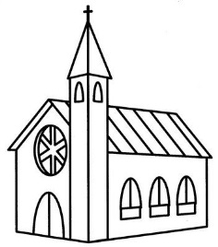

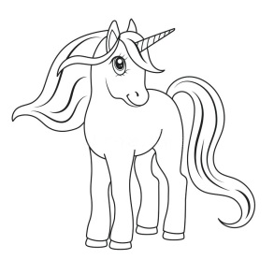

|  |  |  |  |
| --- | --- | --- | --- |
|  |  |  |  |
|  |  |  |  |
|  |  |  |  |

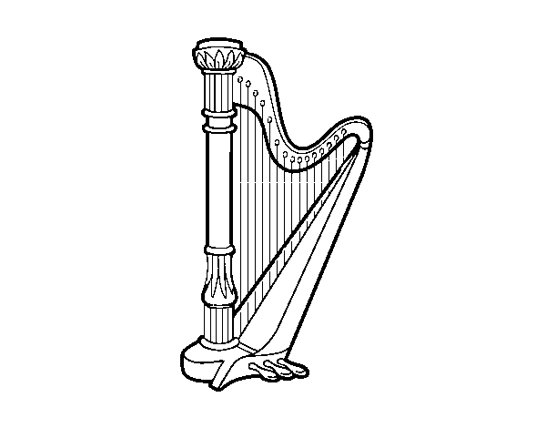

|  |  |  |  |
| --- | --- | --- | --- |
|  |  |  |  |
|  |  |  |  |
|  |  |  |  |

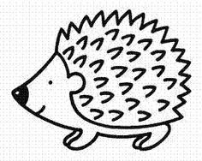

|  |  |  |  |
| --- | --- | --- | --- |
|  |  |  |  |
|  |  |  |  |
|  |  |  |  |

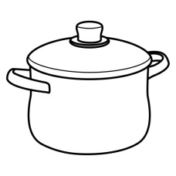4.- Observa la imagen y colorea la vocal inicial:

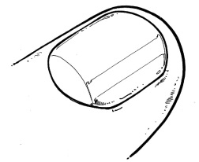

|  |  |  |  |  |
| --- | --- | --- | --- | --- |
| a | e | i | o | u |

|  |  |  |  |  |
| --- | --- | --- | --- | --- |
| a | e | i | o | u |

5.- Pinta la imagen que comienza con el sonido de la letra indicada:

|  |  |
| --- | --- |
| **e** | Resultado de imagen para iguana para colorearResultado de imagen para elefante para colorearImagen relacionada |
| **a** | Resultado de imagen para escoba para colorearResultado de imagen para perro para colorearResultado de imagen para anillo para colorear |
| **i** | Resultado de imagen para isla para colorearResultado de imagen para araÃ±a para colorearResultado de imagen para ojos para colorear |

6.- Escribe en la cuadrícula tu nombre con letra manuscrita.

|  |  |  |  |  |  |  |  |  |  |  |  |  |  |  |  |  |  |  |  |  |  |  |  |  |  |  |  |  |  |
| --- | --- | --- | --- | --- | --- | --- | --- | --- | --- | --- | --- | --- | --- | --- | --- | --- | --- | --- | --- | --- | --- | --- | --- | --- | --- | --- | --- | --- | --- |
|  |  |  |  |  |  |  |  |  |  |  |  |  |  |  |  |  |  |  |  |  |  |  |  |  |  |  |  |  |  |
|  |  |  |  |  |  |  |  |  |  |  |  |  |  |  |  |  |  |  |  |  |  |  |  |  |  |  |  |  |  |
|  |  |  |  |  |  |  |  |  |  |  |  |  |  |  |  |  |  |  |  |  |  |  |  |  |  |  |  |  |  |

|  |  |  |  |  |  |  |  |  |  |  |  |  |  |  |  |  |  |  |  |  |  |  |  |  |  |  |  |  |  |
| --- | --- | --- | --- | --- | --- | --- | --- | --- | --- | --- | --- | --- | --- | --- | --- | --- | --- | --- | --- | --- | --- | --- | --- | --- | --- | --- | --- | --- | --- |
|  |  |  |  |  |  |  |  |  |  |  |  |  |  |  |  |  |  |  |  |  |  |  |  |  |  |  |  |  |  |
|  |  |  |  |  |  |  |  |  |  |  |  |  |  |  |  |  |  |  |  |  |  |  |  |  |  |  |  |  |  |
|  |  |  |  |  |  |  |  |  |  |  |  |  |  |  |  |  |  |  |  |  |  |  |  |  |  |  |  |  |  |

|  |  |  |  |  |  |  |  |  |  |  |  |  |  |  |  |  |  |  |  |  |  |  |  |  |  |  |  |  |  |
| --- | --- | --- | --- | --- | --- | --- | --- | --- | --- | --- | --- | --- | --- | --- | --- | --- | --- | --- | --- | --- | --- | --- | --- | --- | --- | --- | --- | --- | --- |
|  |  |  |  |  |  |  |  |  |  |  |  |  |  |  |  |  |  |  |  |  |  |  |  |  |  |  |  |  |  |
|  |  |  |  |  |  |  |  |  |  |  |  |  |  |  |  |  |  |  |  |  |  |  |  |  |  |  |  |  |  |
|  |  |  |  |  |  |  |  |  |  |  |  |  |  |  |  |  |  |  |  |  |  |  |  |  |  |  |  |  |  |

|  |  |  |  |  |  |  |  |  |  |  |  |  |  |  |  |  |  |  |  |  |  |  |  |  |  |  |  |  |  |
| --- | --- | --- | --- | --- | --- | --- | --- | --- | --- | --- | --- | --- | --- | --- | --- | --- | --- | --- | --- | --- | --- | --- | --- | --- | --- | --- | --- | --- | --- |
|  |  |  |  |  |  |  |  |  |  |  |  |  |  |  |  |  |  |  |  |  |  |  |  |  |  |  |  |  |  |
|  |  |  |  |  |  |  |  |  |  |  |  |  |  |  |  |  |  |  |  |  |  |  |  |  |  |  |  |  |  |
|  |  |  |  |  |  |  |  |  |  |  |  |  |  |  |  |  |  |  |  |  |  |  |  |  |  |  |  |  |  |

|  |  |  |  |  |  |  |  |  |  |  |  |  |  |  |  |  |  |  |  |  |  |  |  |  |  |  |  |  |  |
| --- | --- | --- | --- | --- | --- | --- | --- | --- | --- | --- | --- | --- | --- | --- | --- | --- | --- | --- | --- | --- | --- | --- | --- | --- | --- | --- | --- | --- | --- |
|  |  |  |  |  |  |  |  |  |  |  |  |  |  |  |  |  |  |  |  |  |  |  |  |  |  |  |  |  |  |
|  |  |  |  |  |  |  |  |  |  |  |  |  |  |  |  |  |  |  |  |  |  |  |  |  |  |  |  |  |  |
|  |  |  |  |  |  |  |  |  |  |  |  |  |  |  |  |  |  |  |  |  |  |  |  |  |  |  |  |  |  |

|  |  |  |  |  |  |  |  |  |  |  |  |  |  |  |  |  |  |  |  |  |  |  |  |  |  |  |  |  |  |
| --- | --- | --- | --- | --- | --- | --- | --- | --- | --- | --- | --- | --- | --- | --- | --- | --- | --- | --- | --- | --- | --- | --- | --- | --- | --- | --- | --- | --- | --- |
|  |  |  |  |  |  |  |  |  |  |  |  |  |  |  |  |  |  |  |  |  |  |  |  |  |  |  |  |  |  |
|  |  |  |  |  |  |  |  |  |  |  |  |  |  |  |  |  |  |  |  |  |  |  |  |  |  |  |  |  |  |
|  |  |  |  |  |  |  |  |  |  |  |  |  |  |  |  |  |  |  |  |  |  |  |  |  |  |  |  |  |  |

|  |  |  |  |  |  |  |  |  |  |  |  |  |  |  |  |  |  |  |  |  |  |  |  |  |  |  |  |  |  |
| --- | --- | --- | --- | --- | --- | --- | --- | --- | --- | --- | --- | --- | --- | --- | --- | --- | --- | --- | --- | --- | --- | --- | --- | --- | --- | --- | --- | --- | --- |
|  |  |  |  |  |  |  |  |  |  |  |  |  |  |  |  |  |  |  |  |  |  |  |  |  |  |  |  |  |  |
|  |  |  |  |  |  |  |  |  |  |  |  |  |  |  |  |  |  |  |  |  |  |  |  |  |  |  |  |  |  |
|  |  |  |  |  |  |  |  |  |  |  |  |  |  |  |  |  |  |  |  |  |  |  |  |  |  |  |  |  |  |

|  |  |  |  |  |  |  |  |  |  |  |  |  |  |  |  |  |  |  |  |  |  |  |  |  |  |  |  |  |  |
| --- | --- | --- | --- | --- | --- | --- | --- | --- | --- | --- | --- | --- | --- | --- | --- | --- | --- | --- | --- | --- | --- | --- | --- | --- | --- | --- | --- | --- | --- |
|  |  |  |  |  |  |  |  |  |  |  |  |  |  |  |  |  |  |  |  |  |  |  |  |  |  |  |  |  |  |
|  |  |  |  |  |  |  |  |  |  |  |  |  |  |  |  |  |  |  |  |  |  |  |  |  |  |  |  |  |  |
|  |  |  |  |  |  |  |  |  |  |  |  |  |  |  |  |  |  |  |  |  |  |  |  |  |  |  |  |  |  |

|  |  |  |  |  |  |  |  |  |  |  |  |  |  |  |  |  |  |  |  |  |  |  |  |  |  |  |  |  |  |
| --- | --- | --- | --- | --- | --- | --- | --- | --- | --- | --- | --- | --- | --- | --- | --- | --- | --- | --- | --- | --- | --- | --- | --- | --- | --- | --- | --- | --- | --- |
|  |  |  |  |  |  |  |  |  |  |  |  |  |  |  |  |  |  |  |  |  |  |  |  |  |  |  |  |  |  |
|  |  |  |  |  |  |  |  |  |  |  |  |  |  |  |  |  |  |  |  |  |  |  |  |  |  |  |  |  |  |
|  |  |  |  |  |  |  |  |  |  |  |  |  |  |  |  |  |  |  |  |  |  |  |  |  |  |  |  |  |  |

|  |  |  |  |  |  |  |  |  |  |  |  |  |  |  |  |  |  |  |  |  |  |  |  |  |  |  |  |  |  |
| --- | --- | --- | --- | --- | --- | --- | --- | --- | --- | --- | --- | --- | --- | --- | --- | --- | --- | --- | --- | --- | --- | --- | --- | --- | --- | --- | --- | --- | --- |
|  |  |  |  |  |  |  |  |  |  |  |  |  |  |  |  |  |  |  |  |  |  |  |  |  |  |  |  |  |  |
|  |  |  |  |  |  |  |  |  |  |  |  |  |  |  |  |  |  |  |  |  |  |  |  |  |  |  |  |  |  |
|  |  |  |  |  |  |  |  |  |  |  |  |  |  |  |  |  |  |  |  |  |  |  |  |  |  |  |  |  |  |