**Calificación**

Guía de Autoaprendizaje

ASIGNATURA: INGLÉS

**UNIDAD I: TIME**

Nombre: ___________________________________ Curso: ___7°_____ Fecha de entrega: _________

|  |  |
| --- | --- |
| **OA:** | Demostrar comprensión de textos no literarios, relacionados con funciones y temas de la unidad, identificando información general y específica: ideas principales, tipo, fuente y propósito de los textos; detalles; relaciones de causa, efecto, contraste, causa y consecuencia. |

|  |
| --- |
| **INSTRUCCIONES GENERALES:**  - Lee atentamente la instrucción para cada ítem.  - Puedes utilizar diccionarios ya sea físicos o virtuales. NO utilices traductores para el texto.  - Al término de la Guía, esta debe ser archivada en una carpeta para ser presentada al final del período de suspensión de clases. |
| **MAIL DE CONTACTO:** Claudio.vars@gmail.com |

|  |
| --- |
| **Para la revisión y el cálculo de la calificación de la guía se considerará:**  - El puntaje total de la guía es de 15 puntos.  - La nota mínima (4,0) se obtendrá con el 60% del puntaje total de la guía.  - El uso de ortografía correcta en los ítems que requieren redacción.  - La selección clara y única de cada alternativa en los ítems que corresponda. |

**I. Read the text and do the activities below.**

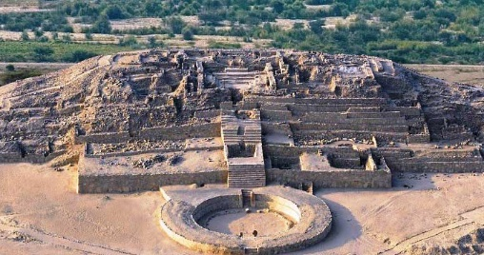**The City of Caral**

The civilization of Supe was the first civilization of the Americas. Caral was their capital city. Caral is an ancient city that included agricultural sites, rich culture, pyramids, temples, platforms, amphitheaters, streets, public squares and residential areas. The city was discovered in the XX century by the Archeologist Paul Kosoc.

The city of Caral is situated in the Supe Valley in the north of Peru. The word “Caral” means “Oasis” in the Quechua language. The ruins of the city are well-preserved. The city is famous for its wonderful architecture. When the city was active, there were many pyramidal structures and residences of the elite. These characteristics indicate that Caral was influenced by a clear religious ideology.

In the center of Caral there was a central public area with six large pyramids. The largest pyramid was 20 meters high and the base was of 150x150 meters. This pyramids covered and area similar to 4 football stadiums. The pyramids were religious and administrative centers. The governors used the pyramids to monitor the entire city.

It is estimated that the number of people that lived in Caral was of about 3,000. Archeologists suppose that the design of Caral influenced other civilizations of Northern Peru. In 2001, the city of Caral was declared a World Heritage Site by the UNESCO.

Taken and adapted from: <https://ieltsliz.com/reading-practice-ancient-city-caral/>

**A. Complete with information from the text.** 1p/each.

**1. Name of the city:** ____________________________.

**2. Name of the civilization:** ____________________________.

**3. Location (Country):** ____________________________.

**4. Function of the pyramids: _________**________________________________________________________.

**5. number of people:** ____________________________.

**B. Circle the correct alternative according to the text.** 1p/each.

|  |  |
| --- | --- |
| **1. Caral was a _______ city.**   1. American. 2. European. 3. Chilean. | **6. The People of Caral were influenced by _______.**   1. Pyramids. 2. Religion. 3. Residences. |
| **2. In Caral there were _______.**   1. Stadiums. 2. Cathedrals. 3. Temples. | **7. It is FALSE that: ________.**   1. There were 4 football stadiums in Caral. 2. The central public area had 6 pyramids. 3. The largest pyramid was 20 meters high. |
| **3. Paul Kosoc was _______.**   1. A citizen of Caral. 2. An archeologist. 3. A Peruvian investigator. | **8. It is true that other civilizations ________.**   1. Destroyed the city of Caral. 2. Imitated the design of Caral. 3. Invaded the city of Caral. |
| **4. The city’s name means _______.**   1. Supe. 2. Oasis. 3. Valley. | **9. The text is _______.**   1. Instructive. 2. Informative. 3. Argumentative. |
| **5. The most famous characteristic of the city is:______.**   1. Its architecture. 2. Its conservation. 3. Its location. | **10. The text is from a…**   1. A newspaper. 2. A catalogue. 3. A webpage. |