Calificación
Guía de Autoaprendizaje

ASIGNATURA: INGLÉS
UNIDAD I: ADVICE AND SUPPORT

Nombre: ___________________________________ Curso: ___3°M_____ Fecha de entrega: _________

OA: | Leer un texto y demostrar comprensión identificando información de carácter general y específico.

INSTRUCCIONES GENERALES:
- Lee atentamente la instrucción para cada ítem.
- Puedes utilizar diccionarios ya sea físicos o virtuales.
- Al término de la Guía, esta debe ser archivada en una carpeta para ser presentada al final del período de suspensión de clases.
MAIL DE CONSULTAS Y RETROALIMETACIÓN: Claudio.vars@gmail.com

Para la revisión y el cálculo de la calificación de la guía se considerará:
- El puntaje total de la guía es de 28 puntos.
- La nota mínima (4,0) se obtendrá con el 60% del puntaje total de la guía.
- El uso de ortografía correcta en los ítems que requieren redacción.

I. Use a dictionary to find the Spanish meaning of these concepts. 1p/each.

1. Beginning (n) ____________________________________
2. Shy (adj) ____________________________________
3. Annoyed (adj) ____________________________________
4. Get out of hand (v) ____________________________________
5. Together (adv) ____________________________________
6. Feeling (n) ____________________________________
7. Spend (time) (v) ____________________________________
8. Parents (n) ____________________________________

II. Complete these sentences. Use the concepts from activity I. 1p/each.

1. Sometimes it is difficult to express your ___________________________in front of people.

2. The teacher told us to work _______________________, not individually.

3. If the situation ______________________, call the police.

4. In the __________________________of the movie, the protagonist have a car accident.

5. My sister_________________________ most of her time chatting on her cellphone.

6. I got 3,0 on the exam. My _______________________ will be furious.

7. I don’t……………………the instructions. Can you explain them to me.

8. This jacket does not…………………me. It’s too small for me.

III. Read the text and do activities A, B and C. 1p/each.

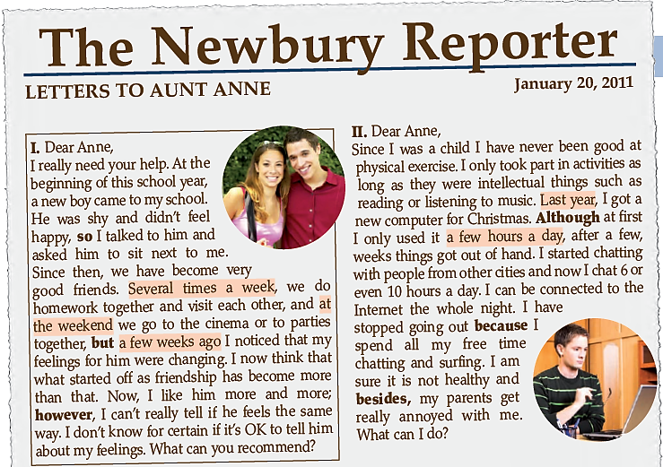

A. Circle the correct alternative. 1p/each.

LETTER I | LETTER II
1. The writer of letter I is:  - A boy.  - A girl.  - A woman.  - A men. | 5. The writer of letter II is described as:  - Not very sociable.  - A sports person.  - A Christmas lover.  - A good friend.
2. Where did the girl and the boy meet?  - At the cinema.  - At a party.  - At school.  - At the mall. | 6. He received a new computer in:  - January.  - October.  - December.  - April.
3. The girl’s problem is:  - She likes her friend.  - She is shy.  - The boy is shy.  - Her boyfriend is unhappy. | 7. The boy’s problem is:  - He loves his internet friends.  - He spends too many hours online.  - His computer is very fast.  - He is addicted to computer games.
4. The letter in general is about:  - Friendship.  - Fear of confessing feelings.  - Activities together.  - Depression. | 8. The letter in general is about:  - Christmas presents.  - Going ut with friends.  - Technology addiction.  - School responsabilities.

B. Answer in English. 1p/each.

1. What activities do the kids in Letter I do together?

………………………………………………………………………………..……………………………………………..……………………………………………

………………………………………………………………………………..……………………………………………..……………………………………………

2. How long does the writer of Letter II spend chatting on the Internet?

………………………………………………………………………………..……………………………………………..……………………………………………

………………………………………………………………………………..……………………………………………..……………………………………………

C. Correct these false statements. Use literal information from the text. 1p/each.

1. The writer of Letter I doesn’t see this boy very often.

………………………………………………………………………………..……………………………………………..……………………………………………

………………………………………………………………………………..……………………………………………..……………………………………………

2. The writer of Letter II goes out very often.

………………………………………………………………………………..……………………………………………..……………………………………………

………………………………………………………………………………..……………………………………………..………………………………………….

